- Analysis of different visualizations plots.
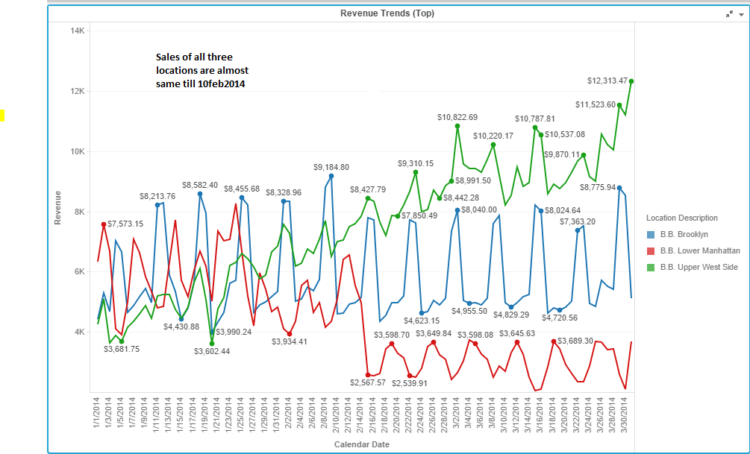
Sales is almost same for all three location till 02/10/2014 (02nd February 2014).
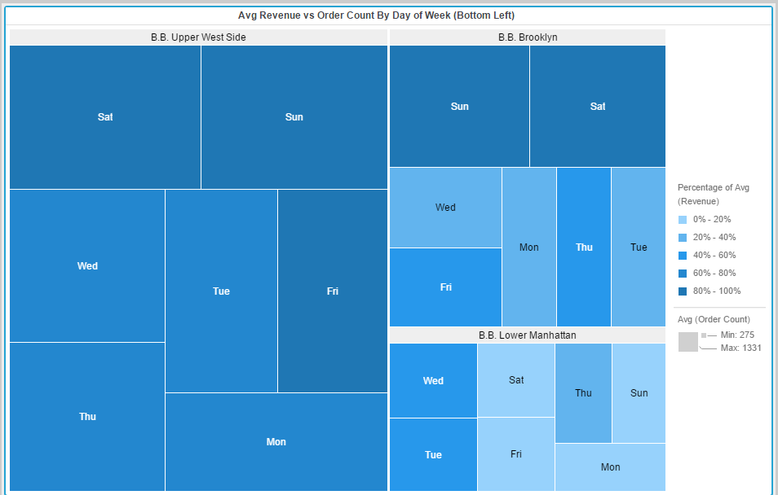

A heat map is a two-dimensional representation of data in which values are represented by colors. A simple heat map provides an immediate visual summary of information. More elaborate heat maps allow the viewer to understand complex data sets. Here we can observe the Average Order Count and Average Revenue at specific week day and location.

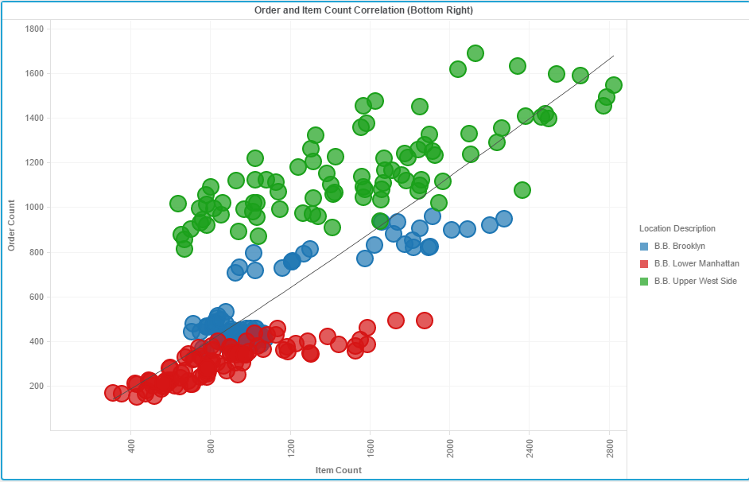

A bubble chart is a variation of a scatter chart in which the data points are replaced with bubbles, and an additional dimension of the data is represented in the size of the bubbles. Just like a scatter chart, a bubble chart does not use a category axis — both horizontal and vertical axes are value axes.). It shows the correlation between the Order and item count. A line at 45 degree shows the trend line. Green bubble (upper west side) is above trend line performing best and vice versa for red bubble (B.B. Lower Manhattan) performing worst.

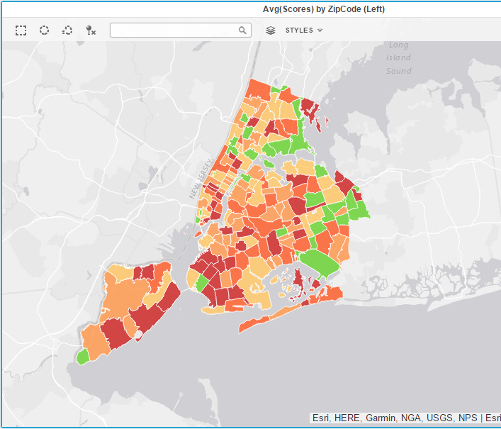
In this visualization red color representing the zip code of the states performing lower score where Zip code in green performing highest score.
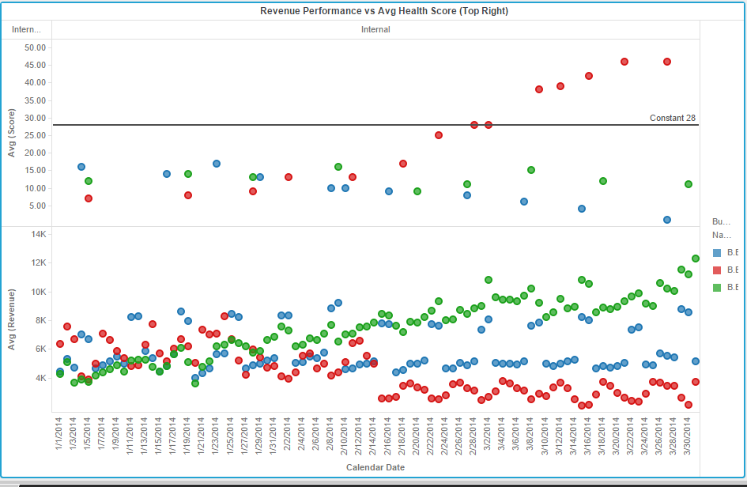

This Visualization shows that how health score affects the revenue at 3 locations. Avg(Score) is most for Red (Lower Manhattan) corresponding to lowest revenue.

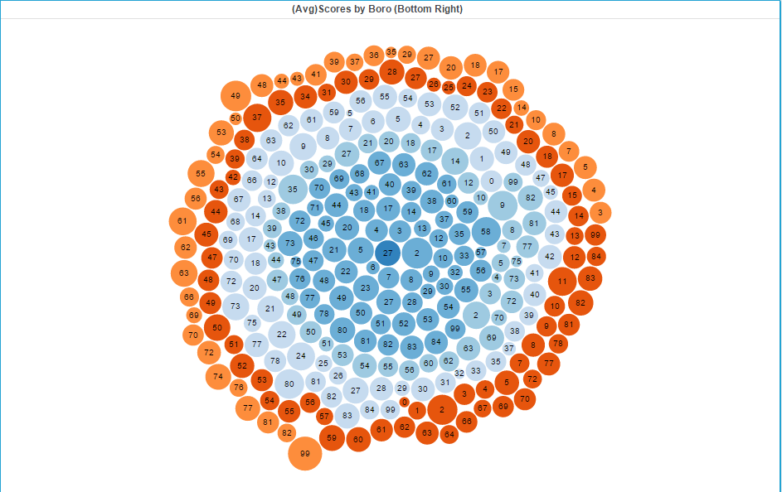
This is the bubble 3D visualization shows average score by bottom right.

- Other type of visualizations that can be used are
Column-chart and Bar-graph for plotting the total number of orders and sales at all 3 locations.

